DATE HERE - info, figures, whatever afterwards, DATE EVERYTHING

09/10/2022 – Image detection literature study

<https://www.mygreatlearning.com/blog/introduction-to-edge-detection/>

Edge detection described as: “a technique of image processing used to identify points in a digital image with discontinuities, simply to say, sharp changes in the image brightness”

There are several methods, all involvi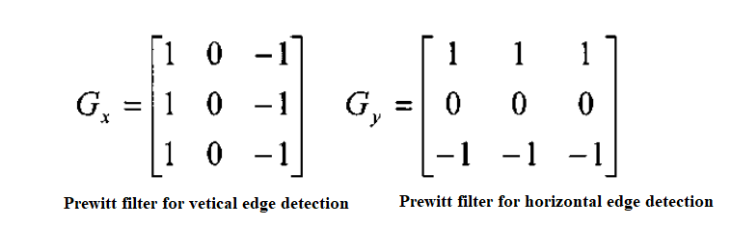ng applying a filter matrix to the image at all possible points.

For all given pixels that the matrix will fit for, apply these coefficients for a given pixel, then sum the values and take this as the new value to be later normalized for the image:

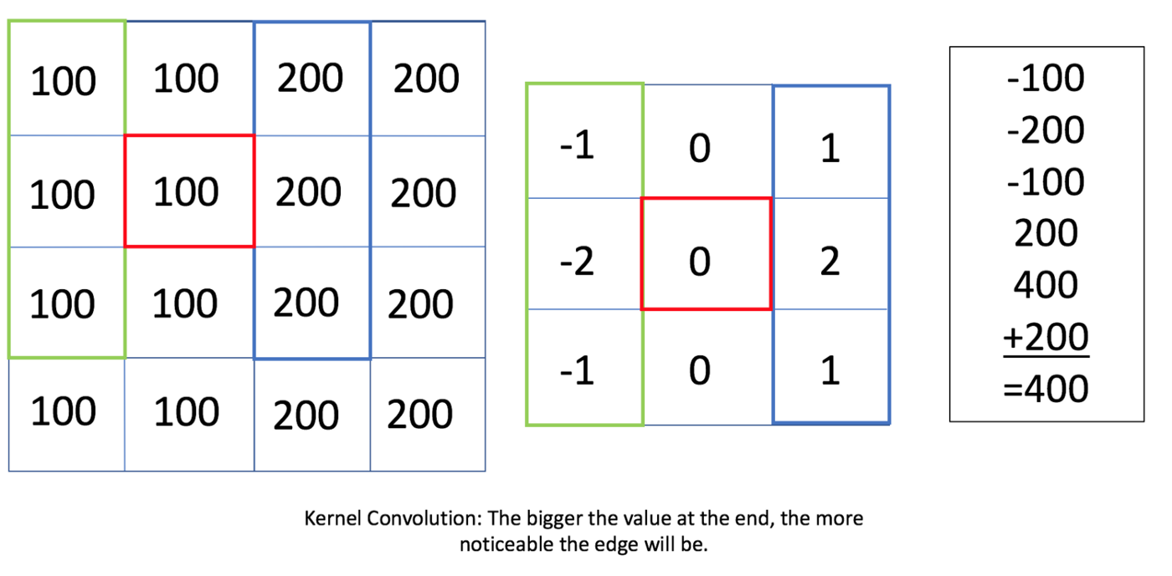

This method results in the output being shrunk in dimensions, for an n\*n image and a r\*r filter the output image will be ( (n-r)+1)\*( (n-r)+1).

Canny edge detection is the most common. The process involves:

* Convert the image to grayscale
* Reduce noise – as the edge detection that using derivatives is sensitive to noise, we reduce it.
* Calculate the gradient – helps identify the edge intensity and direction.
* Non-maximum suppression – to thin the edges of the image.
* Double threshold –  to identify the strong, weak and irrelevant pixels in the images.
* Hysteresis edge tracking – helps convert the weak pixels into strong ones only if they have a strong pixel around them.

Attempt to impement a Sobel filter in MATLAB: